CREATE JAVA APPLICATION

Uncheck Create main class

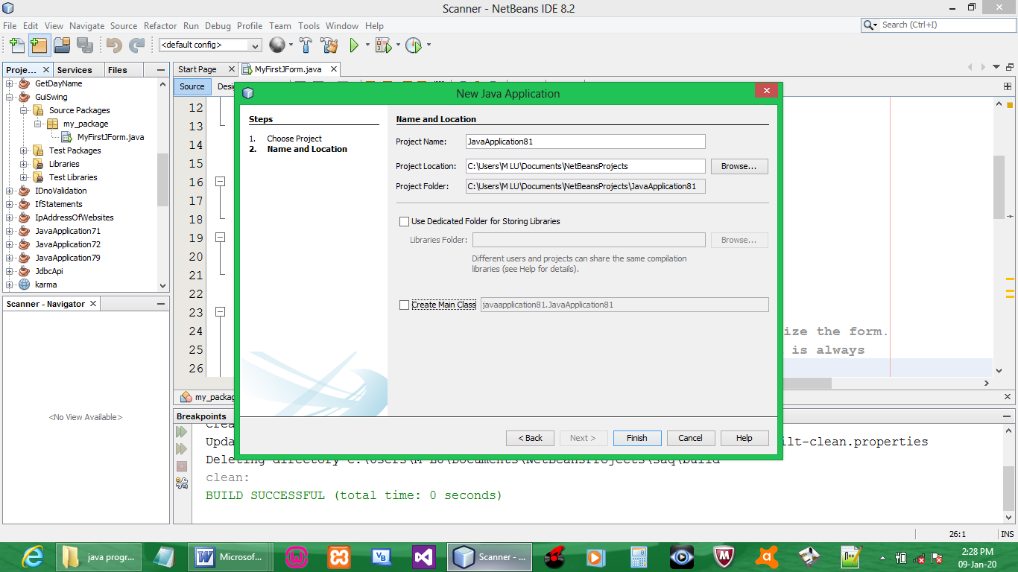

Create Java Package

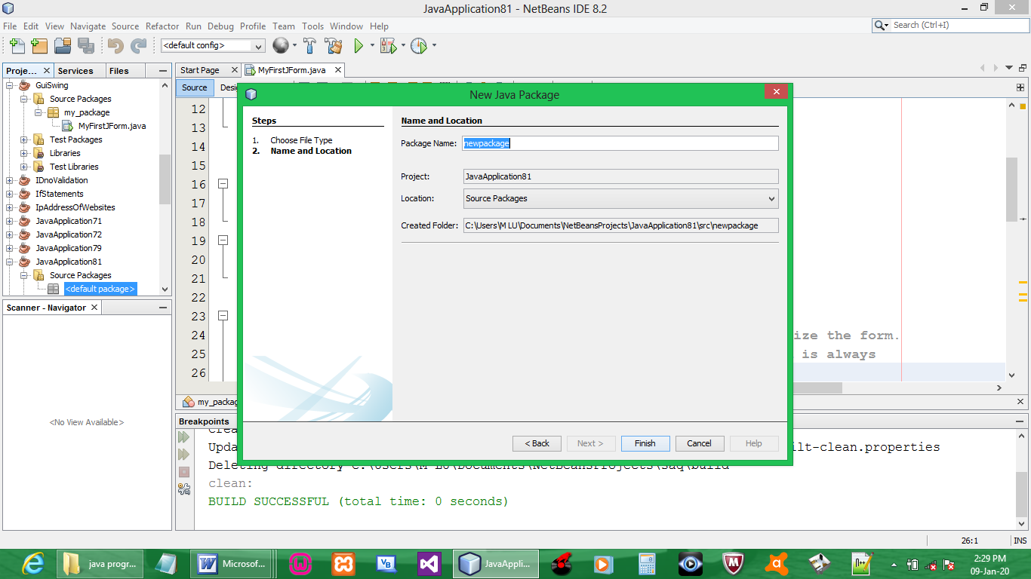

Create JFrame

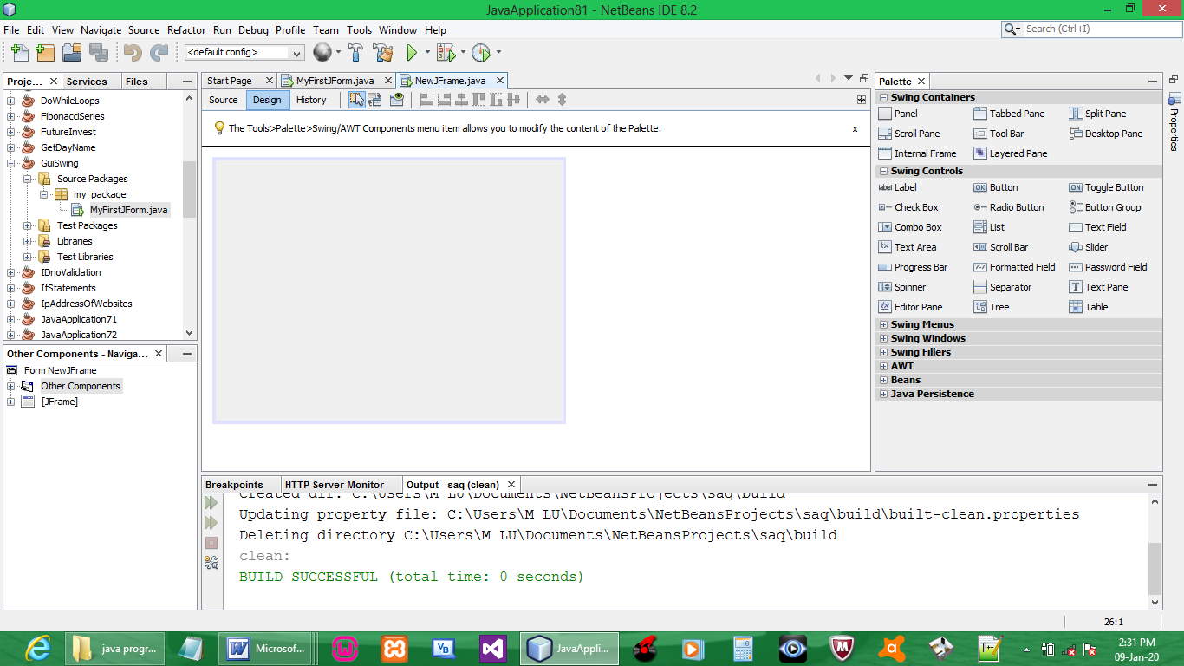

Drag button to the frame

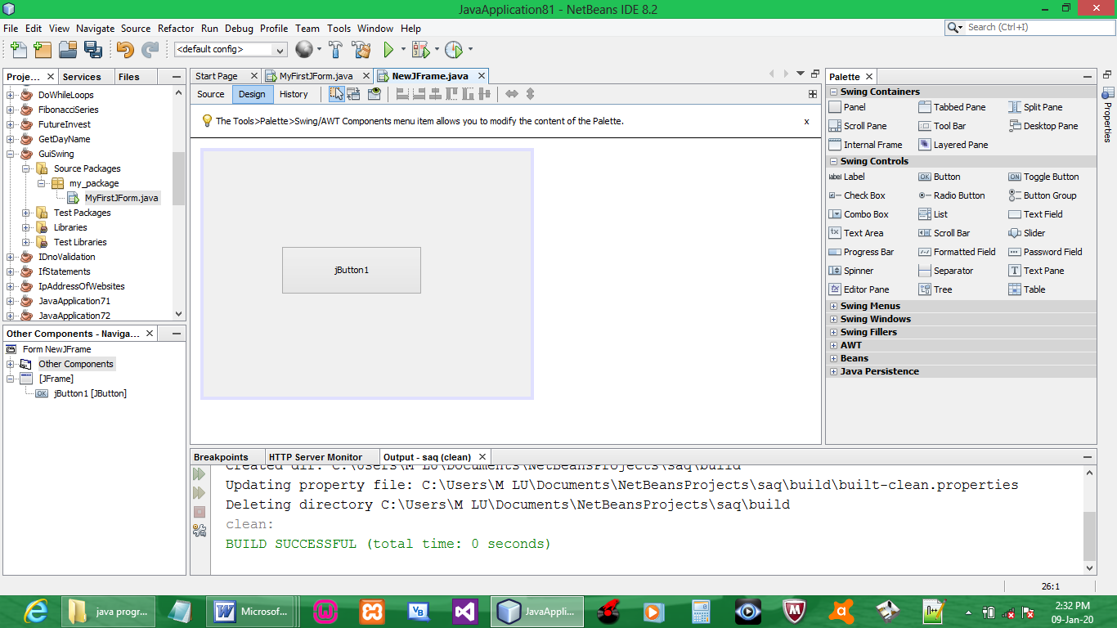

Double click the button

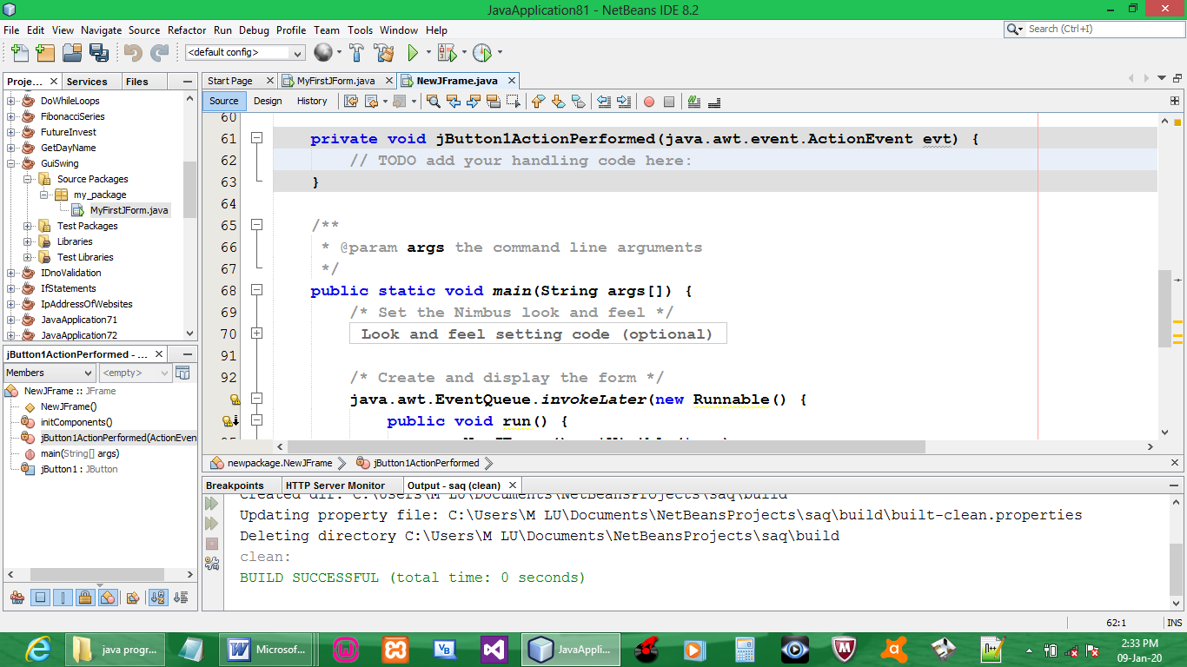

Import:

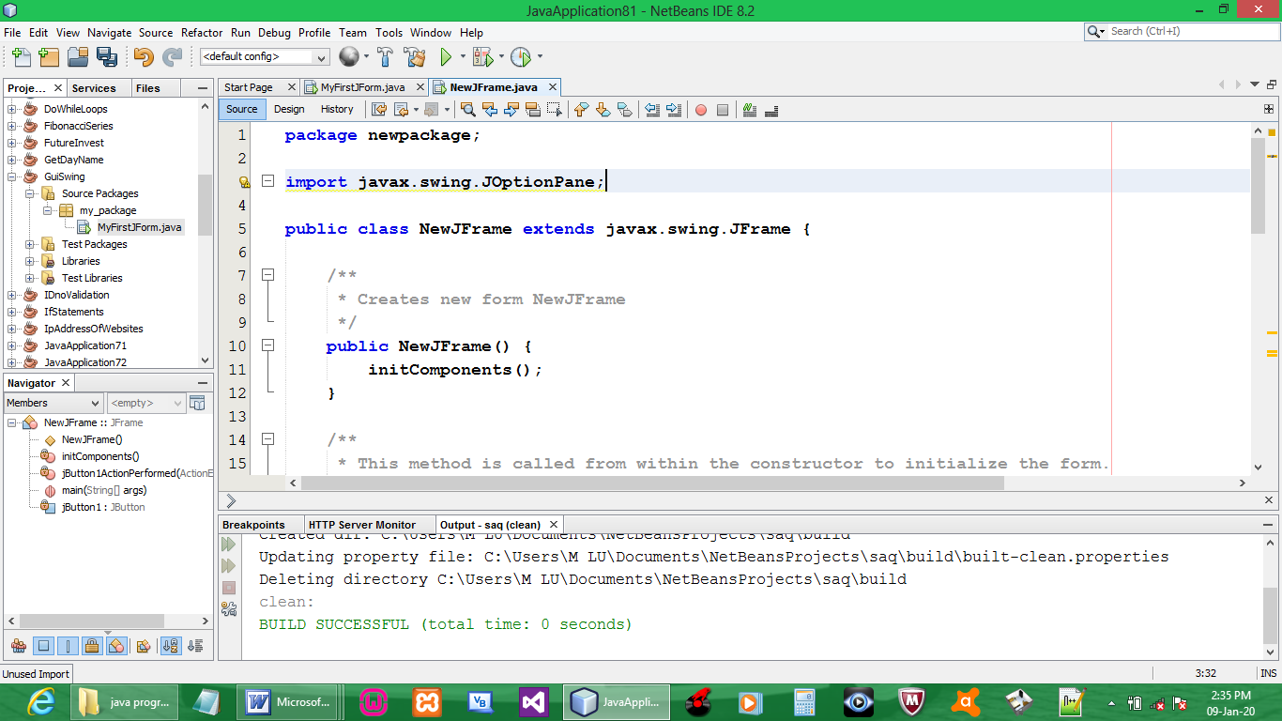

CODE:

private void jButton1ActionPerformed(java.awt.event.ActionEvent evt) {
JOptionPane.showMessageDialog(this,"FIRST GuiSwing");
}

OUTPUT:

